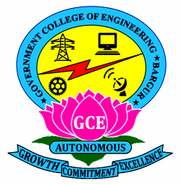

**GOVERNMENT COLLEGE OF ENGINEERING BARGUR**

**( AUTONOMOUS)**

**PROJECT TITLE: MEASURE ENERGY CONSUMPTION**

**TEAM MEMBERS:**

**SRI LAKSHMI NARAYANA G C**

**SELVA KUMAR S**

**SENTHIL KUMAR R**

**GOVINDARAJ S**

**ARUN PANDIAN V**

**PROBLEM STATEMENT:**

**The measure energy consumption involves finding effective methods and tools to accurately monitor and track the amount of energy consumed by various devices, appliances, or systems. This includes developing technologies that can collect and analyse data on energy usage, such as smart meters or energy monitoring systems. The goal is to provide individuals, businesses, and organizations with the necessary information to make informed decisions about their energy consumption and identify areas where energy efficiency improvements can be made. The challenge lies in designing user-friendly and cost-effective solutions that can provide real-time or historical data on energy usage while ensuring data privacy and security.**

**PROBLEM SOLUTION :**

* **To solve the problem of measuring energy consumption, several solutions can be implemented.**
* **One solution is to use smart meters or energy monitoring devices that provide real-time data on energy usage.**
* **These devices can be installed at the point of consumption, such as individual appliances or entire buildings, and provide detailed information on energy consumption patterns.**
* **Additionally, data analytics techniques can be applied to this data to identify trends, anomalies, and potential areas for energy efficiency improvements.**
* **This can help individuals and organizations make informed decisions about their energy usage and take steps to reduce their overall consumption.**
* **To measure energy consumption, another solution is to implement home energy management systems.**
* **These systems utilize smart technology to monitor and control energy usage in residential settings.**
* **They can provide real-time data on energy consumption, offer insights on energy-saving opportunities, and even automate energy usage based on user preferences.**
* **By empowering individuals to track and manage their energy consumption, these systems can help promote energy efficiency and reduce overall energy usage.**